Electrical Engineering
Student’s Name
Course Department, Institutions
Course Code, Course Name
Instructor’s Name
Date

Electrical Engineering
Introduction
In the current competitive market, understanding the structure of the costs of commodities is important in improving the process and pricing strategy. The metal stamping process involves the use of stamping presses and dies to change the sheet metals into different shapes (Shanbhag, et al., 2018). In the company of the sheet metal, the traditional process of production commences from metal sheets while using laser cutting and punching machines. The scraps obtained in the stamping process are expected to generate profits. In the production of the boxes, on the standardized sheets, the sections are nested on the surface of the sheet of metal. The production process of the sheet metal product includes several phases from the raw material to the final product ready for sale in the market. The positioning needs to consider the account constraints because of the place of the grippers and optimization of the material to produce a quality box. When the manufacturers consider the standardized size of the sheets and boxes, the company has chances of optimizing the length to fit the exact number. In the process, the cost of production and annual profits by the end of the year should be calculated. The report aims at providing the annual report of the Sheet Industry and identifying the best option to maximize the profits.
Calculation of the Manufacturing Cost of the Boxes from the Sheet metal
The cost of production of the boxes from metal sheets is affected by the different parameters such as reliability of the machine, or the daily cost, based on the number of estimations and planned decisions the management has considered. The management of the company needs to consider the factors while deciding on the method of production of the boxes from the sheets for quality production.
The first step involves breaking down the production process. Since the production cycles can be different, the production should be broken into simple processes as shown:
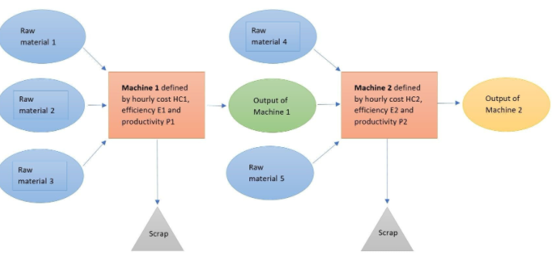
If the logistics of the products between the two systems are carried on and made automatic, by the storage or machines, the phase is considered different in the production of the boxes. An automatic strategy of the machine is featured by its different hourly or daily cost of production leading to the highest cycle causing upstream of the production process. The output of the machines easily traced based on the cost of production.
Calculation of the Cost of Materials
The manufacturing process of the boxes from the sheets requires raw materials. The company, for instance, requires 1 sheet to produce 1200 stamping operations transformed into 15 boxes. Thus, the raw material is metal sheets. For a single production, one metal sheet is needed. The material required is based on the gain of the company
Cost of raw material= no. sheets x cost
1x10.40
=10.40x5x50
= 2600 euros annually
Cost of Machining
The cost of machining requires the daily cost of the machine system and will not involve the cost of the overheads. The cycle(productivity) and efficiency(reliability) of the system are included in the calculation of the cost of machining.
Machining cost=daily cost x cycle time for one box
Reliability of the machine
=1.15x1
0.8
=1.4375 x 5 x 50
= 359.375 euros annually
The value of machining represents 13.8% of the cost of the raw material showing that any saving on the raw material with elimination or optimization of the scraps, will be of benefit to the general cost of production.
Thus, the total production cost will be calculated as:
Total production cost=coast of raw material+ cost of machining+ cost of labor
Cost of labor= 340x5x50
=85 000 euros/year
Total cost of production: 85 000 + 2600+359.375
=87959.375
Total return for the company= 80x15x5x50x0.85
=255 000 Euros/year
Annual income profit= 255,000-87959.375
=167 040.625
Since the machine is not 100% reliable, the company’s trying to come up with options helping in maximizing the profits for the success of the firm in the competitive market.
For most of the items, clients are not aware of the amount to calculate per day on the machine. The management needs to decide on the value of the overhead linked to the operation of the machine, the gross margin profit to be earned and the daily rate generally used in the market (Ilic & Jaddivada, 2020). The invested cost of the machine is calculated based on the number of years the machine is to be repaid. For the machine to be upgraded, the investment cost:
Investment cost per day= investment value
Payback period x estimated days of operation
= 100 000
5x1200
=16.67/day
Machining cost=daily cost x cycle time for one box
Reliability of the machine
= 1.15x1/0.85
=1.352x5x50=338
Total cost=85000+338+4 167.5
=89 505.5
Payable to the bank=(100,000x7.5x5/100)
= 37 500
Profit margin= 127 994.5 Euros per year.
Option 2
Machining cost=daily cost x cycle time for one box
Reliability of the machine
0.90x1
0.92
=0.98x5x50
245 Euros
Labor cost=85 000
Investment cost= 515 000
10x1250
41.2 x5x50
=10 300
Total cost of production=95 545
Margin Profit=159 455.
Conclusion
To maximize the profits, the sheet makers need to make informed decisions. The calculations done in the report shows some strategic evaluation and decisions that manufacturers have to make for effective payback to the company. The current metal forming industry is surrounded by optimization in all the activities done. The lean production helps the company to identify the wastes and reduce them as much as possible (Sathish, 2018). The outlined options are necessary for the success of the company in the competitive market. To generate more return for the company, it needs to purchase the new machine and install it with percentage reliability of 92. The option has provided more return for the company and is expected to improve the profit margin for the sheet industry. The laser cutting machines are utilized for productivity. This provides the possibility of avoiding about 15% of the wastes. During the production process, the management needs to consider the highlighted factors such as reliability, the production rate and the machine daily costs. This will help in generating the high efficiency constant of the machine and system. The modern system of production applied in the company in the production of the boxes is efficient in the manufacturing process reducing the setup times for a change of the tools as shown in the calculations. Even with the high automated machines in option 2, the costs of the Machines are represented reducing the raw material cost. Thus, any saving in the material of producing the boxes reduces the cost and becomes beneficial in form of reduction of the overall cost in the industry.

References
Ilic, M., & Jaddivada, R. (2020). Unified value-based feedback, optimization and risk management in complex electric energy systems. Optimization and Engineering, 1-57.
Sathish, T. (2018). Prediction of spring-back effect by the hybridization of ANN with PSO in wipe bending process of sheet metal. Progress in Industrial Ecology, an International Journal, 12(1-2), 112-119.
Shanbhag, V. V., Rolfe, B. F., Arunachalam, N., & Pereira, M. P. (2018). Investigating galling wear behavior in sheet metal stamping using acoustic emissions. Wear, 414, 31-42.
.

